#RBCGIVING Social Media Guide

Spread the word about Richard Bland College’s participation in #GivingTuesday - and help us reach the entire Richard Bland College community by sharing #RBCGiving posts on Facebook, posting photos on Instagram and staying active on Twitter as well. Download our social media guide (PDF) for even more social post ideas. Follow our progress on all social media platforms and keep the momentum going all day long with the hashtag #RBCGIVING

SOCIAL MEDIA IMAGES
Changing your profile picture and cover photo to support #GivingTuesday for RBC is easy. Just right-click on the image you want (or tap and hold on your phone) and save it to your computer or phone's photo gallery. Then, go to the social media page you want to change, click on your profile photo/cover photo and upload the photo when it prompts you to. The images are already the correct size.

PROFILE PHOTOS
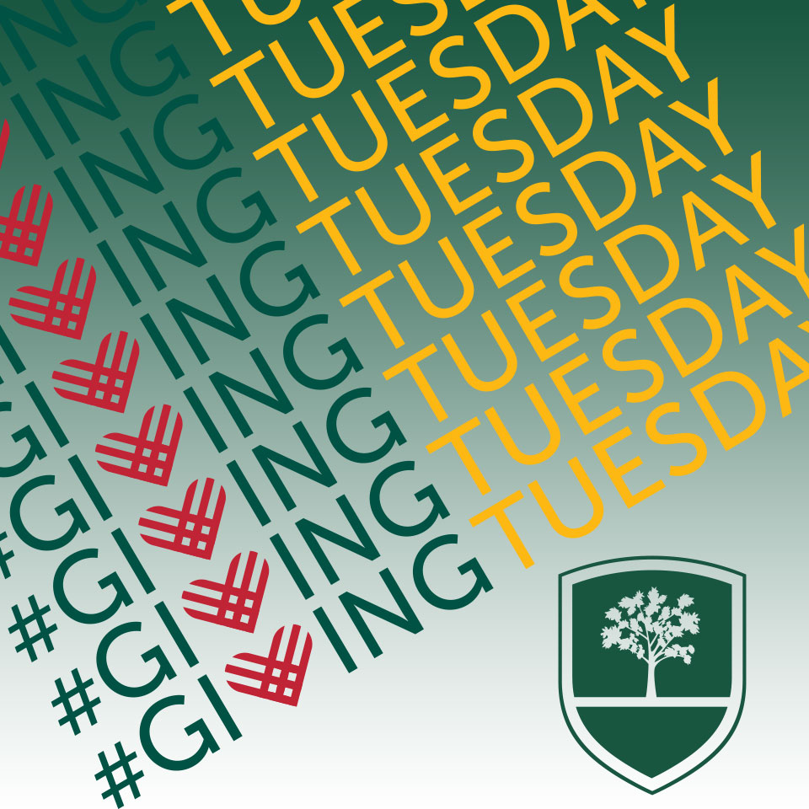

COVER PHOTOS

