Practice Placement Test Instructions

Follow the instructions below to access and complete the PRACTICE Placement Test

- Go to https://learn.hawkeslearning.com
- Select Create an Account
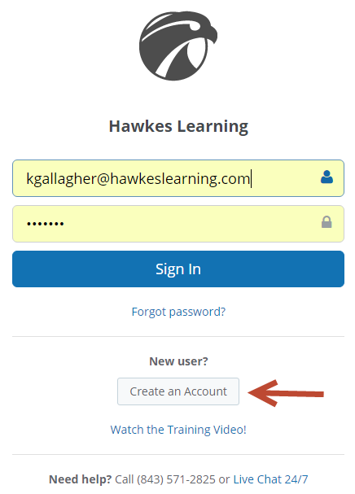
- Select Request Temporary Access
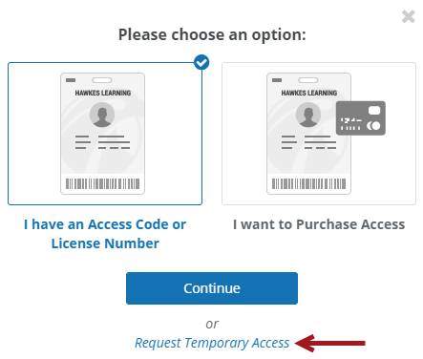

- Create an account with password and security questions. Be sure to enter a working email address that you will be able to access!
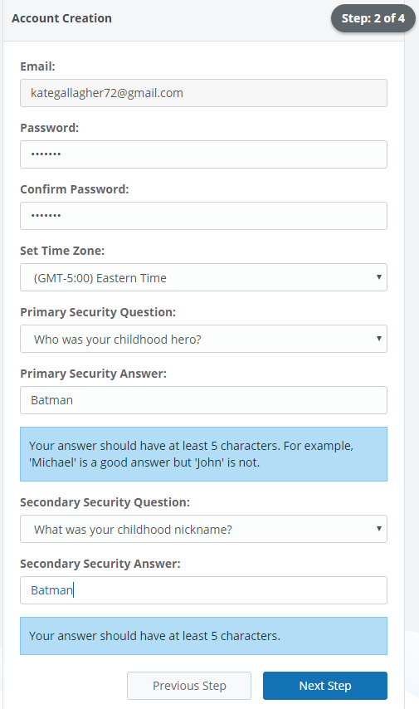

- Select the following during the enrollment process:
Product: Placement Test
Instructor: Placement Test
Section: Placement Test
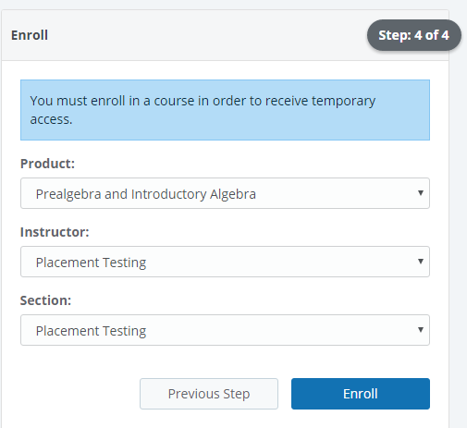

- Verify email address and then sign in
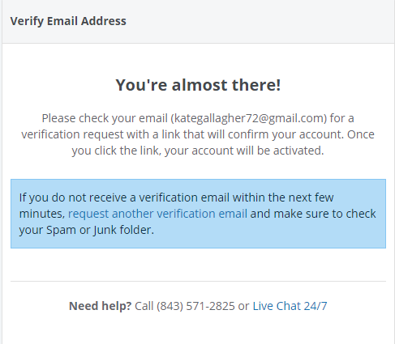
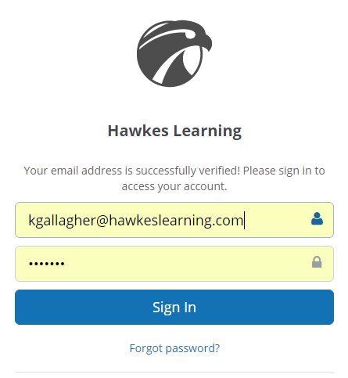

- On your Dashboard, select the PRACTICE Placement Test

- Select Start to begin. You will be prompted to enter a password that the testing center coordinator will provide
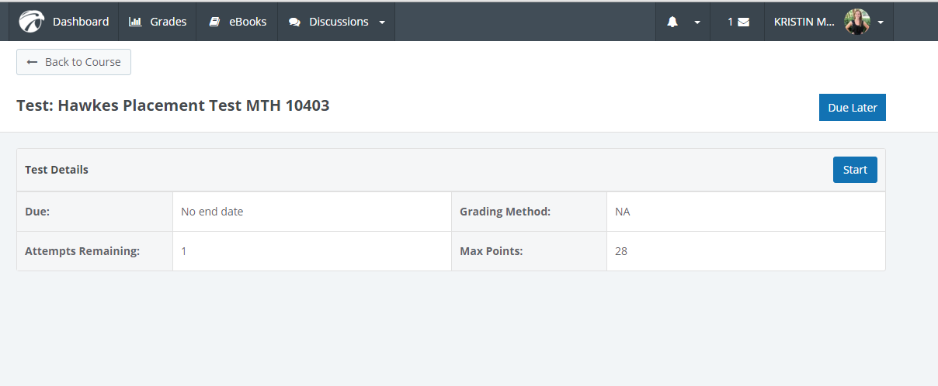

- Go through your test and when finished select Turn in test
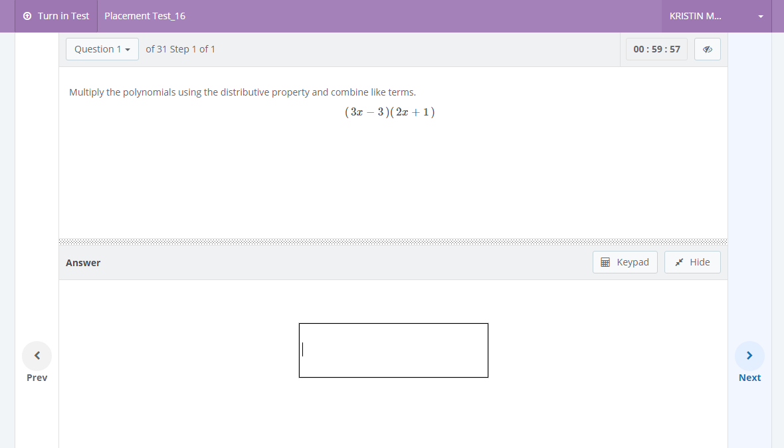

- After completing the Practice Test, your results will immediately display allowing you to fully review all questions and the correct answers if you select “Review” or click to practice missed questions if you select the results bar above any lesson:
